Docker Task-3

Step1:

Created the directory in instance called myweb and html and inside the html directory kept the index.html file

Screenshot mentioned below:

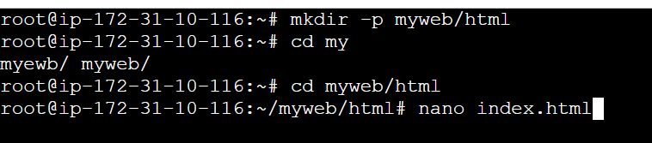

Index.html

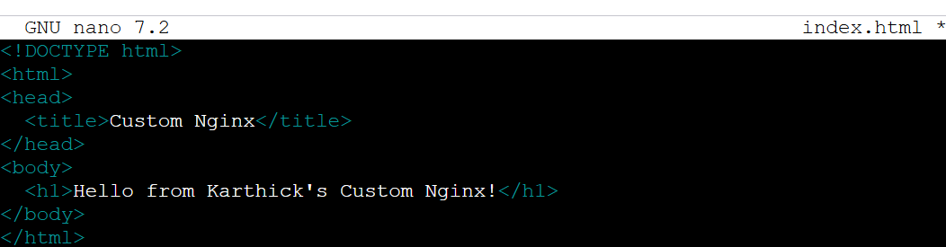

Step2:

And created the Docker file using the volume path we set it in manual

Screenshot mentioned below:

Dockerfile.yaml

C:\My folder\Devops_MainBoot_Info\Task\Task_13.06.2025\Screenshot 2025-06-26 171731.png

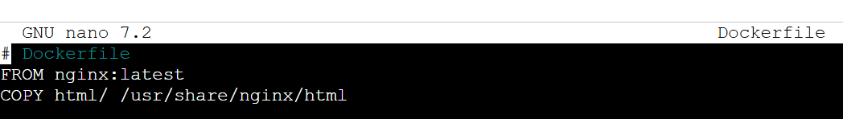

And inside the dockercompose.yaml file

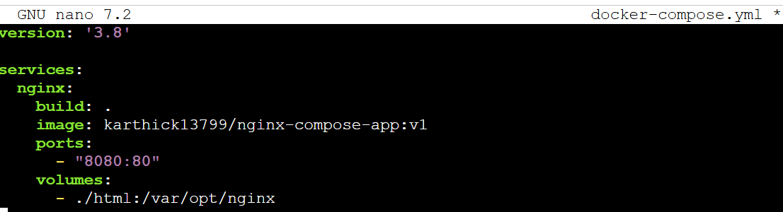

Step4:

Using docker-compose up and build it and we created an custom image using this command

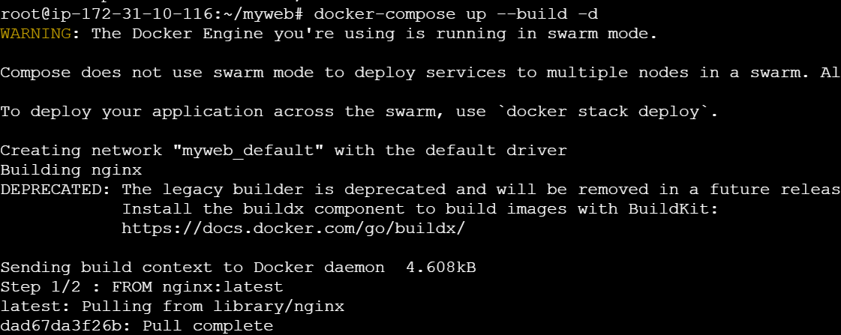

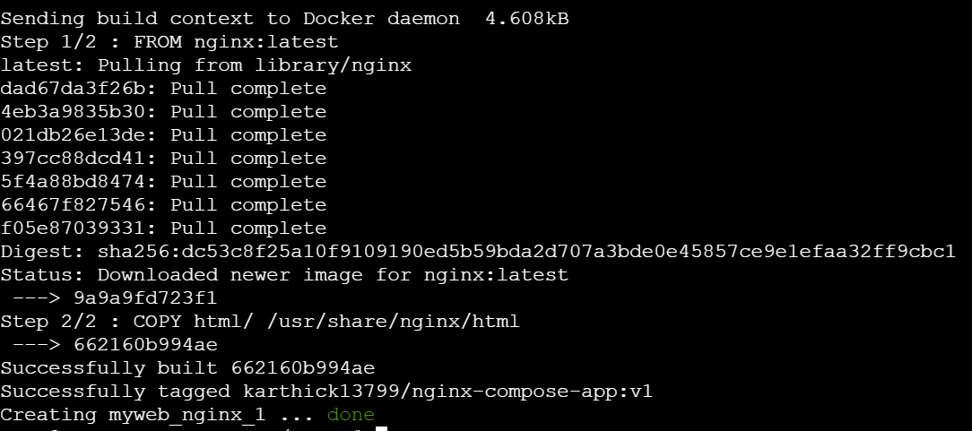

After that if we hit the public Ip we gone through the link

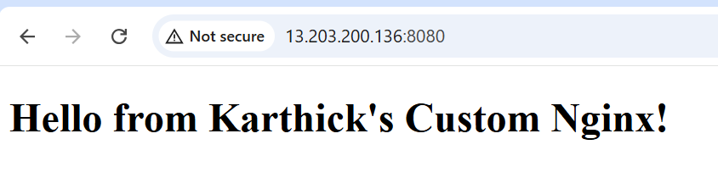

Step5:

And for the created image we need to pull into the dockerhub

So for that we created the tag into that and push to dockerhub

Screenshot mentioned Below:

